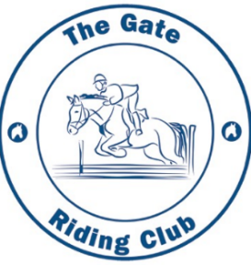
THE GATE RIDING CLUB
THE SHOW GROUND COTON ROAD
WHITACRE HEATH
COLESHILL
B46 2HL
Dressage SCHEDULE
2026

www.gateridingclub.co.uk
The Gate Riding Club Group



This show is affiliated to Equine Sports UK (ESUK) Grassroots Championship taking place at Arena UK Grantham Lincolnshire on 30th July to 1st August 2026. The THREE highest placed exhibits will qualify in each class
SHOW DATES 2026
29th March 2026 Club Show inc. SJ
5th April 2026 Dressage
26th April 2026 Club Show inc. SJ
3rd May 2026 Dressage
31st May 2026 Club Show inc. SJ and Dog Show
7th June 2026 Dressage
28th June 2026 Club Show inc. SJ - Medal Show
5th July 2026 Dressage
26th July 2026 Club Show inc. SJ
2nd August 2026 Dressage
8th August 2026 The Gate RC @ Canwell Show Ground Not Gate RC
30th August 2026 Club Show inc. SJ - Sash Show
6th September 2026 Dressage
27th September 2026 Club Show inc. SJ
4th October 2026 Dressage Championship
11th October 2026 Club Show inc. S J

Members and non-members welcome to every competition
Entries via My Riding Life search for Gate Riding Club
https://myridinglife.com/myridinglife/onlineentries.aspx
Points towards trophies will be awarded to members only
Please see Website for more information throughout the show season and for any changes.
www.gateridingclub.co.uk

Entries via My Riding Life only
Entry confirms that you have 3rd party liability

DRESSAGE
Classes to start at 9:30 prompt
All dressage classes ESUK and NPS qualifiers

5th April |  | 3rd May
Class 1 | Intro 1 | Class 1 | Intro 2
Class 2 | Intro 2 | Class 2 | Intro 3
Class 3 | Prelim 1 | Class 3 | Prelim 2
Class 4 | Prelim 2 | Class 4 | Prelim 3
Class 5 | Novice 1 | Class 5 | Novice 2
Class 6 | Novice 2 | Class 6 | Novice 3
Class 7 | Elem 1 | Class 7 | Elem 2
Class 8 | Elem 2 | Class 8 | Elem 3
7th June |  | 5th July
Class 1 | Intro 3 | Class 1 | Intro 1
Class 2 | Intro 4 | Class 2 | Intro 2
Class 3 | Prelim 1 | Class 3 | Prelim 2
Class 4 | Prelim 2 | Class 4 | Prelim 3
Class 5 | Novice 1 | Class 5 | Novice 2
Class 6 | Novice 2 | Class 6 | Novice 3
Class 7 | Elem 1 | Class 7 | Elem 2
Class 8 | Elem 2 | Class 8 | Elem 3
2nd August |  | 6th September
Class 1 | Intro 2 | Class 1 | Intro 3
Class 2 | Intro 3 | Class 2 | Intro 4
Class 3 | Prelim 2 | Class 3 | Prelim 1
Class 4 | Prelim 3 | Class 4 | Prelim 3
Class 5 | Novice 2 | Class 5 | Novice 1
Class 6 | Novice 3 | Class 6 | Novice 3
Class 7 | Elem 2 | Class 7 | Elem 1
Class 8 | Elem 3 | Class 8 | Elem 3
DRESSAGE CHAMPIONSHIP 4th October
Class 1 Intro 2 Class 2 Intro 4
Class 3 Prelim 2 Class 4 Prelim 3
Class 5 Novice 2 Class 6 Novice 3
Class 7 Elem 2 Class 8 Elem 3
Anyone placed 1st to 6th in any class throughout the season will qualify for the Championship.
The championship classes will be split to qualified and non-qualified
Member’s points will be awarded 1st – 6th and will count towards the Annual Trophies for Dressage. No side reins or running reins allowed in warm up. Classes will be judged under BD rules. Times will be available on My Riding Life.

LR and assisted riders can have help inside the arena

Rosettes to 6th place.
ENTRIES via MY RIDING LIFE, please click the link & search for Gate Riding Club

www.myridinglife.com/myridinglife/onlineentries.

Please provide your own numbers one on each side of the saddle cloth or bridle
Please note that Juniors are Under 18yrs as of 01 01 2025. ALL CLASSES SPLIT JNR/SNR
If numbers allow we will split Juniors to Under 12 too

Dressage entry fee: GRC members £10:00 Non Members £13:00
First Aid £4.00 per rider
READERS £1.00 per class

This show is affiliated to Equine Sports UK (ESUK) Grassroots Championship taking place at Arena UK Grantham Lincolnshire on 30th July to 1st August 2026. The THREE highest placed exhibits will qualify in each class

RULES & CONDITIONS
The Gate Riding Club and / or the organising committee cannot be held responsible for any accident, damage, injury or illness to horses, ponies, riders, owners, grooms, ground spectators or any other person or property whatsoever other than the liability for a refund of entry fee in the event of abandonment of the competition.

HEALTH & SAFETY
The organisers of this event have taken all responsible precautions to ensure Health & Safety of everyone present. For these measures to be effective everyone must take all responsible precautions to avoid accidents occurring and must obey the instructions of the organiser and all officials and stewards.

SHOW SAFETY
1 All persons on the showground must comply with the safety advice and directions given by Club officials and displayed on safety notices.
2 All riders when riding, whether competing or not, must wear hard hats meeting the standard.
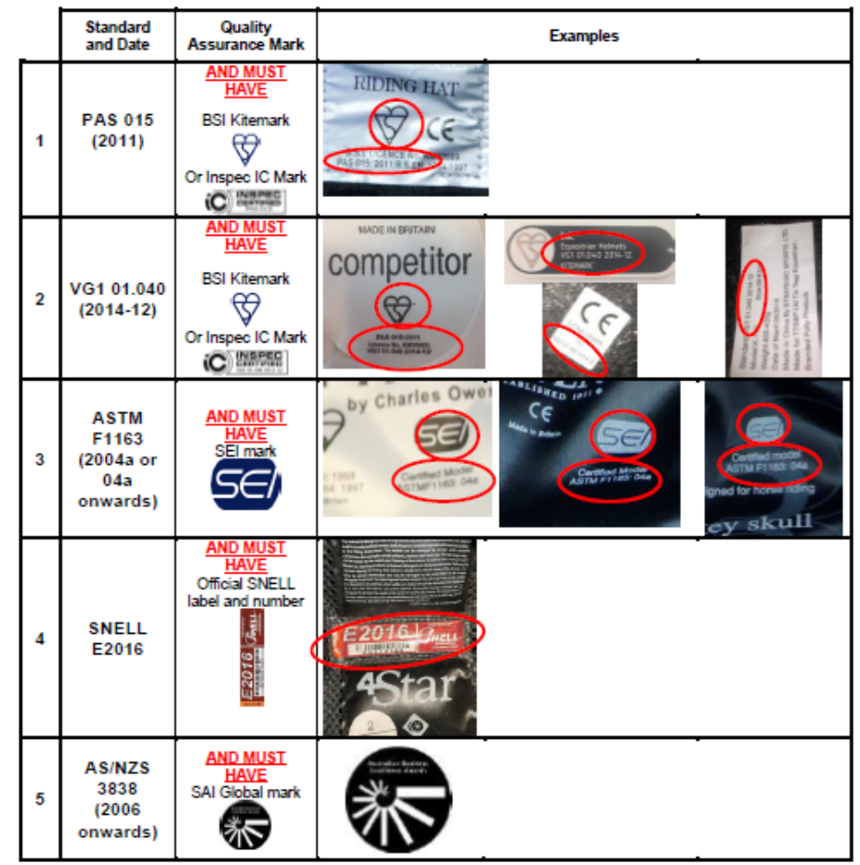
3 Appropriate protective clothing, including footwear must be worn by all persons on the showground when mounted.
4 Entries accepted at rider’s risk.
5 The organisers reserve the right to refuse an entry at their discretion, cancel, amend or amalgamate any class for any reason whatsoever.
6 The organiser’s decision is final.
7 Only riders entered to compete in the show may use the practice ring Grooms and owners are not eligible to use this facility.
8 A fall of the rider will result in elimination from the competition. Such dismounted riders should not remount whilst in the collecting ring or dressage arena.
9 Competitors should be mounted on suitably sized ponies or horses. Should a judge or show official be concerned that a rider is under or over-horsed they will be requested to withdraw in the interests of safety or animal cruelty .
10 All Competitors must have 3rd party liability.

BHS Hat Rules
Hats must meet ALL of the requirements of ONE of the rows:

**** Please note any show ground rules ****

